FILE PERMISSION IN LINUX

The organization asked to change the permission for some files in the project directory
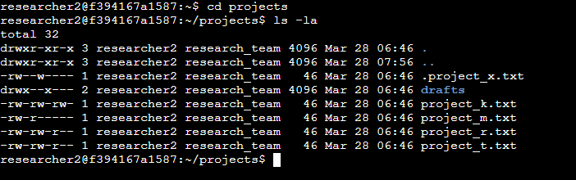
The first line of the screenshot shows the command i used to check the files in the project directories, the ls command with the -la command is used for displaying the file contents and also the hidden files. The output indicates a directory called drafts and an hidden file called .project_x and other 5 files. The first 10 letters show rappresent the permissions for those files or directories.

These files have those current permissions:
- .project_x.txt
User = read and write
Group = write
Other = none
- project_k.txt
all of them have read and write
- project_m.txt
User = read and write
Group = read
Other = none
- project_r.txt
User = read and write
Group = read and write
Other = read
- project_t.txt
User = read and write
Group = read and write
Other = read

The first letter of the 10 characters if is a d means that is a directory, if is a hyphen (-) is a file
The 2nd to 4th characters are the permissions for the user, the 5th to the 7th are for the group and the last 3 characters are for the other, the r permission stands for read, the w stands for write and the x stand for execute
The organization doesn’t want any others to be able to modify any file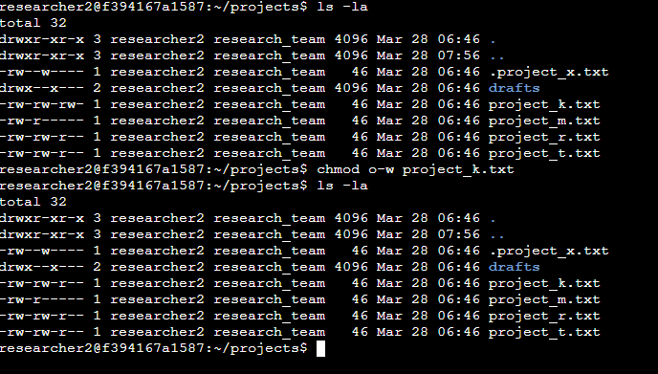
So i used the chmod command to change thew permission of write for other in the project_m to none by writing the o for other minus the w

The hidden file should not have the possibility to be written but only to be read by user and group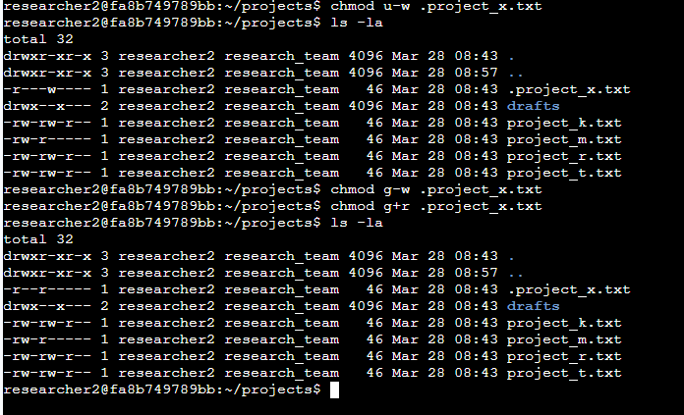
I used the chmod to remove the write permission from the user and the group and gave to group the read permission.
The drafts directory should be allowed to access the drafts directory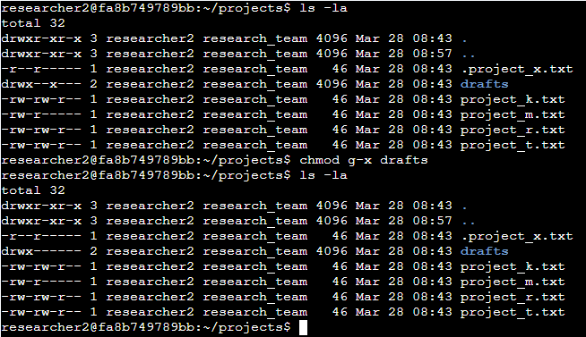
I used chmod to remove the execute permission from the group for the drafts directory.

This is how to use the chmod command to change the permission for files and directories by using linux and what the characters stand for

